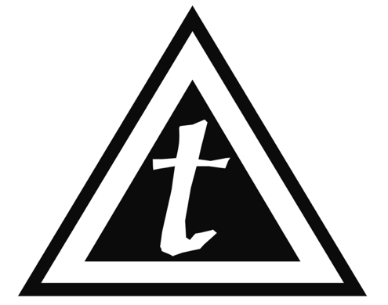
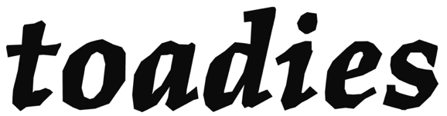
MON CH’s | INPUT | MIC NEEDED | STAND NEEDED
 | 1. KICK 1 (IN)
 | 2. KICK 2 (OUT) |  | SHORT BOOM
 | 3. SNARE TOP | BETA 57
 | 4. SNARE BTM | SM 57
 | 5. HAT | SM 81 | SHORT BOOM
 | 6. RACK 1
 | 7. RACK 2
 | 8. FLOOR | 421 | SHORT BOOM
 | 9. OH SR |  | TALL BOOM
 | 10. OH SL |  | TALL BOOM
 | 11. BASS D.I.
 | 12. BASS MIC |  | SHORT BOOM
 | 13. SR GTR 1 (OUT)
 | 14. SR GTR 2 (IN)
 | 15. SL GTR 1 (IN) |  | SHORT BOOM
 | 16. SL GTR 2 (OUT) |  | SHORT BOOM
 | 17. SR VOX
 | 18. CENTER VOX (58)
 | 19. CENTER VOX (BULLET) | PASSIVE D.I.
 | 20. SL VOX
 | 21. SR PERC | SM 57 | TALL BOOM
 | 22. SL PERC #1 | SM 57 | TALL BOOM
 | 23. SL PERC #1 | SM 57 | TALL BOOM
 | 24. SR AMBIENT | SM 81 | TALL BOOM
 | 25. SL AMBIENT | SM 81 | TALL BOOM

